LeadSquared Integration with Google Apps

Version 1

**Objective**

The objective is to build a Google Contextual Gadget that works with Gmail and allows Gmail users to push sales interactions to LeadSquared.

**How will it work?**

The Gadget will be shown when an email is opened in Gmail.

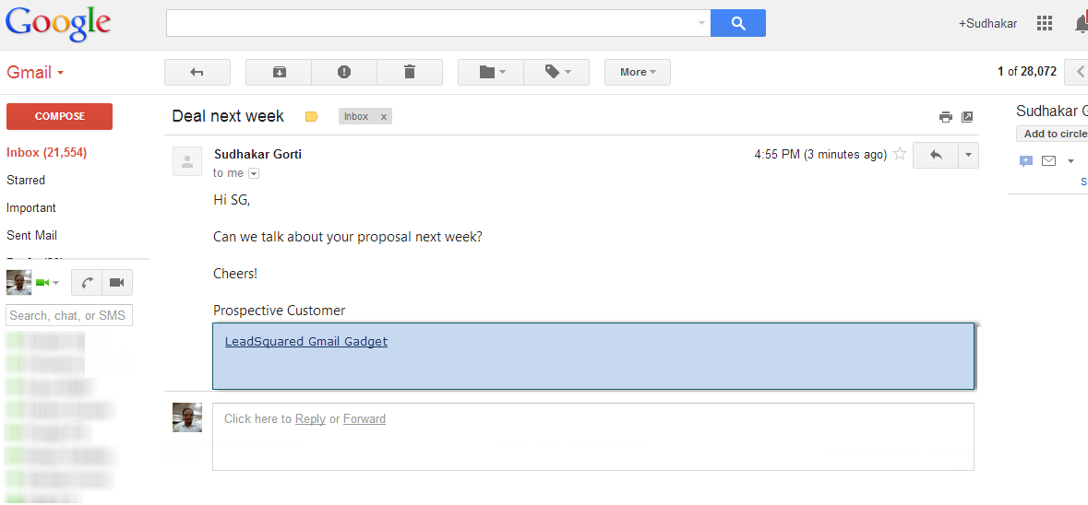

The Gadget will have two scenarios:

1. When the sender of the email is a lead in LeadSquared (how will you find that? Extract the email address and use this API – GET <https://api.leadsquared.com/v2/LeadManagement.svc/Leads.GetByEmailaddres>)
2. When the sender of the email is NOT a lead in LeadSquared.

**Case 1 – Sender is a lead in LeadSquared**

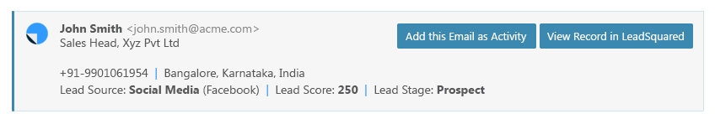

**Case 2 – Sender is NOT a lead in LeadSquared**

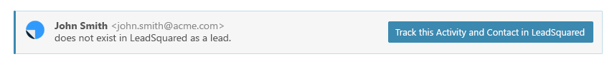

Add the email as activity will use this API:

POST https://api.leadsquared.com/v2/ ProspectActivity.svc/Create - See more at: <http://help.leadsquared.com/leadsquared-api-overview>

This will work well for both Case 1 and Case 2.

**Settings Page:**

You will need to add a settings page for the Admin to set the access key and secret key, so the API will function properly. Where will this be setup?

**Other Items:**

1. The data should be saved to LeadSquared using AJAX
2. If the access key and secret key are not setup, then we should highlight that in the gadget that appropriate settings are to be done.
3. We will send the images that will be required for the gadget.